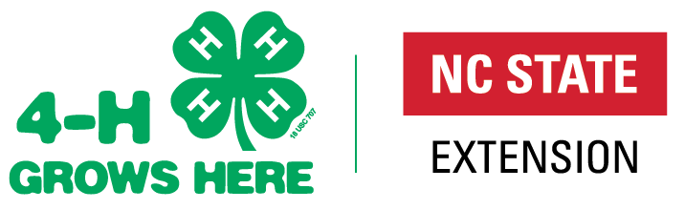

North Carolina 4-H Opportunities
For more information on NC 4-H go to: http://www.nc4h.org
Any Youth 5-18 (as of January 1) can enroll in 4-H Online.

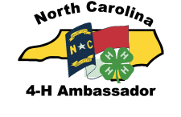
4-H Ambassadors Applicants must be at least 13 years old and a 4-H member for two years as of January 1. 4-H’ers may earn Bronze, Silver, Gold and Emerald Ambassador levels by completing workshops and a portfolio for each level. This program strengthens and expands upon 4-H Ambassadors' current leadership abilities and allows them to serve as positive role models for younger youth. https://nc4h.ces.ncsu.edu/youth-3/4-h-teen-programs/north-carolina-4-h-ambassador-program/ Contact: Shannon McCollum, shannon_mccollum@ncsu.edu

4-H Clubs are a great way to supports long-term youth development and build community amongst our youth, while instilling essential life skills such as leadership, commitment, and nurturing relationship. Whether they are working together on projects in Science & Technology, or focusing their club efforts on environmental awareness, 4-H Club youth learn the importance of becoming engaged in the community, country, and world. 4-H Clubs must consist of at least 5 youth from 3 different families. https://nc4h.ces.ncsu.edu/4-h-professionals/delivery-systems/north-carolina-4-h-clubs/
Contact: Shannon McCollum, shannon_mccollum@ncsu.edu

4-H Entertains is a talent showcase that occurs in conjunction with District Activity Day (DAD). Each county may register two acts to perform at DAD. Acts will then be selected to perform at the state talent show at 4-H Congress in July. County acts perform at County Activity Day and will be selected to perform at District Activity Day. https://nc4h.ces.ncsu.edu/youth-3/4-h-awards-incentives-programs-2/presentations/presentation-guidelines-4-h-entertains/ Contact: Mark Dearmon, mark_dearmon@ncsu.edu

4-H Group Awards that 4-H clubs/groups/counties can apply for each year: The NC 4-H Community Service award (based on community service projects completed by a 4-H club/group) and The 4-H Electric Group Award (based on electric programming completed by the county as a whole or an individual 4-H club/group). One application per county is eligible for State Competition in each of these awards. Applications must be received by the State 4-H Office by March 1. https://nc4h.ces.ncsu.edu/youth-3/4-h-awards-incentives-programs-2/
Contact: Shannon McCollum, shannon_mccollum@ncsu.edu
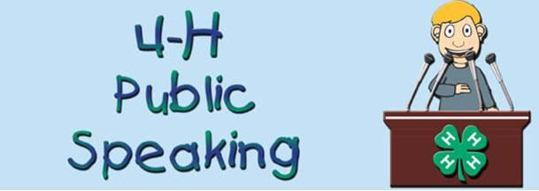
4-H Presentations and Public Speaking allow youth the opportunity to present information by demonstration or illustrated talk for competition. Presentations are judged by subject and age categories (8-10, 11-13, 14-18), Cloverbuds (ages 5-7) may also do presentations, but cannot compete. The time limit is generally between 5 and 12 minutes, with specific time regulations in specific categories. 4-H’ers are selected to compete at district competition through county competitions.
Contact: Shannon McCollum, shannon_mccollum@ncsu.edu

4-H Project Records – highlights what 4-H’ers have learned and done in a specific project area for a period of 12 months. The books are judged by subject and age categories (8-10, 11-12, 13-15 and 16-18), Cloverbuds (ages 5-7) may also turn in a project record book, but these books are not judged. Project Record books are due in the County 4-H office for judging prior submitting the 2 top county winners in each curriculum area to Raleigh for district competition. Age for Project Record competition is based on 4-H’ers age as of Jan 1 of the year the project is completed. Books must be received in the State 4-H Office by March 1. Contact: Shannon McCollum, shannon_mccollum@ncsu.edu

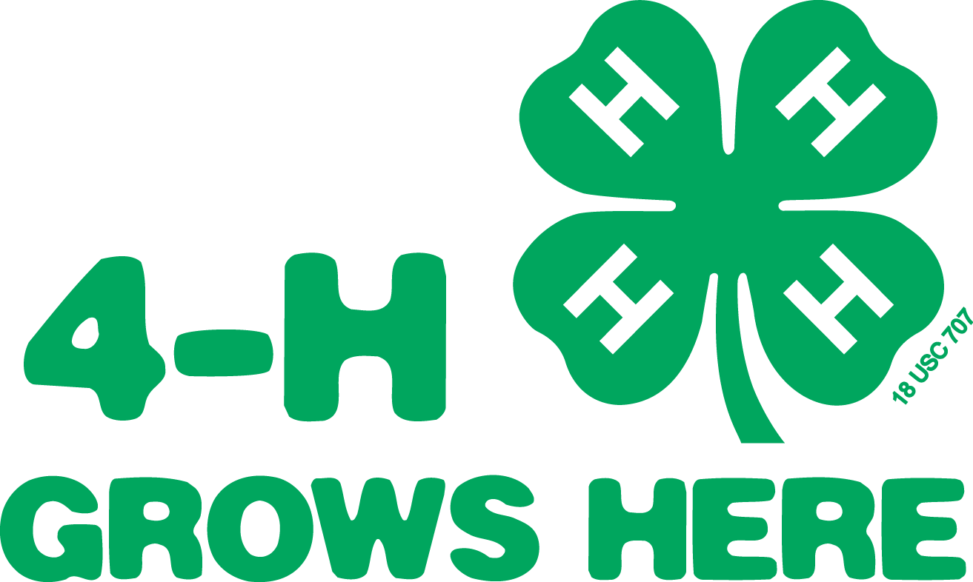
4-H Portfolios are a 3-year accumulation of 4-H project work in a major project area in age categories of 13-15 and 16-18. Portfolios are due in the State 4-H Office by March 1. State winners receive cash awards depending on availability of funds. Contact: Shannon McCollum, shannon_mccollum@ncsu.edu

4-H International Programs is designed for 4-H youth who want the experience of another culture and to gain a global perspective. Youth must be at least 4-H Age 17 and not over 21 years of age.
Contact: Daniel Collins, dpcollin@ncsu.edu, Shannon McCollum, shannon_mccollum@ncsu.edu

Application, Interview, Resume and Essay (AIRE) is due in State 4-H Office May 15. Applications must be at least 14 years old as of January 1. This program is used to select the delegations to attend National 4-H Congress, National 4-H Conference and the International Leadership Conference. Participants must complete a two-page application and submit a resume of no more than two pages and an Essay on How 4-H Has Impacted Their Life. The resume should highlight the 4-H’ers achievements, project work and leadership throughout their career. The County 4-H Agent must sign off on the application before it is submitted. Interviews are held virtually.
Contact: Mitzi Downing, mitzi_downing@ncsu.edu

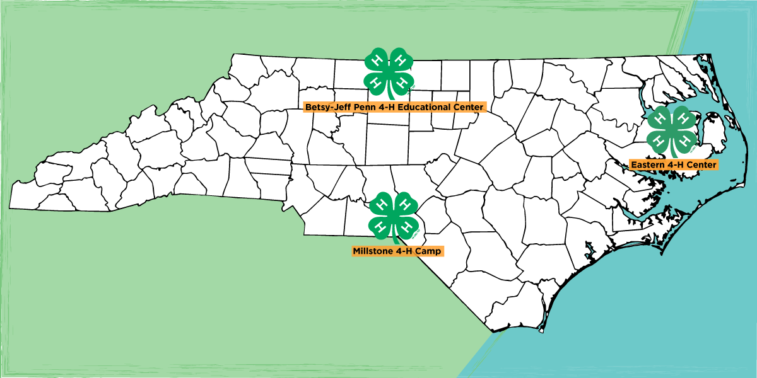
4-H CAMPS offer excellent overnight and day camp opportunities for youth 6-17 at three NC 4-H Centers (Betsy-Jeff Penn, The Eastern Center, and Millstone). Counties may elect to take a group of youth (ages 8-14) to a week of “traditional 4-H camp”. The number of 4-H camp sessions and dates are announced the year before so that 4-H Agents can arrange “multiple county camping groups” if desired. 4-H group’s registration is in the fall for the next summer’s camp. 4-H “Specialty Camps” are also offered and built around a theme (Cloverbud, Marine Science & Sailing, Fur, Fish & Game Rendezvous, Horsemanship Camp, etc.). Opportunities are available for older youth (ages 15-17) to serve as a LIT (Leader in Training). Encourage outstanding 4-H’ers serve as a LIT and apply to be a 4-H Camp Staff member (age 18+). http://www.nc4hcamps.org/
Contacts: Dave Herpy (djherpy@ncsu.edu) or Angela Brisson (aebrisso@ncsu.edu)

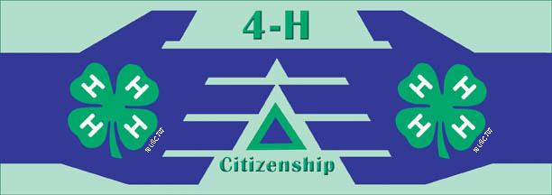
Citizenship NC Focus Hands-on workshops, panel discussions, distinguished speakers and open discussion will help youth discover how government impacts your everyday life, and how you can impact government in return. 4-H’ers will learn about state government, learn about working with public officials, hear from prominent NC officials and visit legislators. Contact: Sarah Kotzian, sarah_kotzian@ncsu.edu

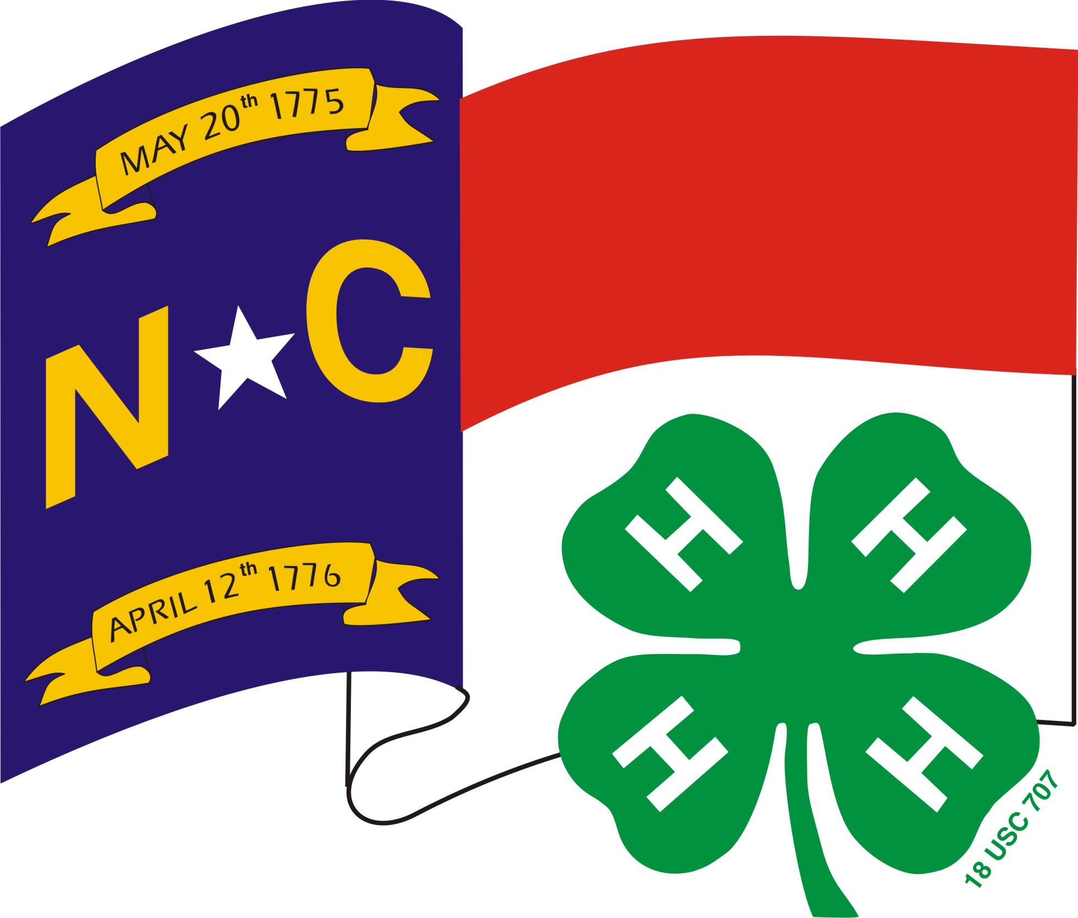
College Scholarships High school seniors may apply for NC 4-H scholarships. Electronic application is due to the State 4-H Office by February 1. The application will allow youth to apply for one or more scholarships. PLEASE note that several scholarships are restricted, and youth MUST meet certain criteria to apply. Scholarship awards range in amounts from $500 to $2000.
Contact: Shannon McCollum, shannon_mccollum@ncsu.edu

Creating and Piloting Curriculum. Each year, content specialists take cutting edge research and turn it into relatable curriculum for use in schools, afterschool programs, camps, and other non-formal education settings. Curriculum content themes include Leadership/Citizenship, Agriculture/Livestock, Health/Life Skills, STEM, etc. Opportunities exist for agents, volunteers, educational partners, and youth to participate in creating and piloting curricula. Each curriculum is built using a content specialist, an advisory team, and an evaluation specialist to make sure it meets rigorous standards to meet the needs of K-12 partners and 4-H. Curricula provides the content from which 4-H programs are developed. Contact: Amy Chilcote, amy_chilcote@ncsu.edu
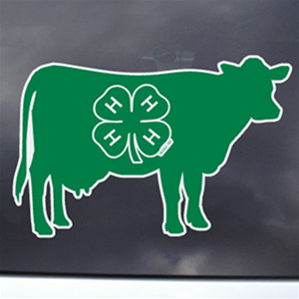
Dairy Events focus on dairy education and include dairy judging, dairy quiz bowl, dairy skill-a-thon, dairy photo contest, numerous dairy shows and national 4-H dairy conference. https://dairy.ces.ncsu.edu/dairy-youth-programs/ Contact: Stephanie Ward, shward@ncsu.edu
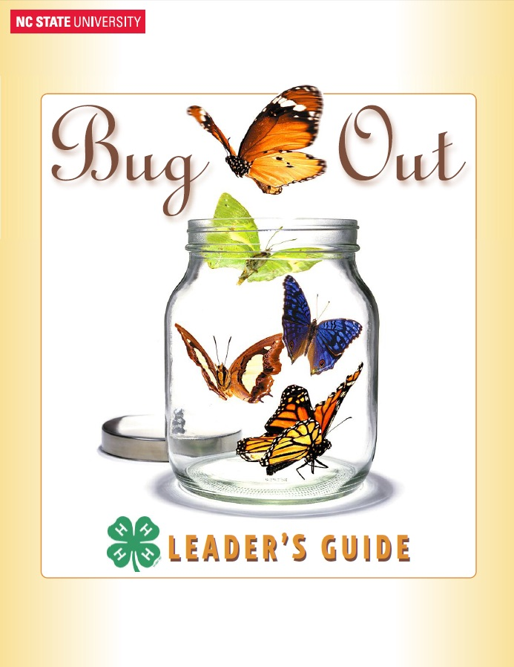
Entomology Events focus on Entomology education and include presentations, Bee-Keeping Essay, insect collections. https://growforit.ces.ncsu.edu/growforit-programs/ Contact: Liz Driscoll, liz_driscoll@ncsu.edu

4-H District Activity Day 4-H’ers advancing from the county level presentation, public speaking, and clothing construction (if applicable will be coordinated by a district contact) contests are able to compete on the district level at District Activity Day. The top winners in presentations and public speaking can compete at the state level contest during 4-H Congress. State winners in sponsored categories receive cash awards. In specific categories, the state-winning seniors may go on to compete at the national level.
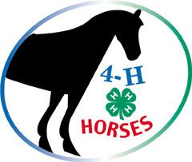
Contact: Shannon McCollum, shannon_mccollum@ncsu.edu

Horse Events focus on horse education and include Equine Expressive Arts Contests, Horse Bowl, Hippology, Retreats, Horse Judging, Horse Shows and Horse Camp. http://www.cals.ncsu.edu/an_sci/extension/horse/Webpages/NCSU_EHH_Home.html
Contact: Alaina Cross, alaina_cross@ncsu.edu
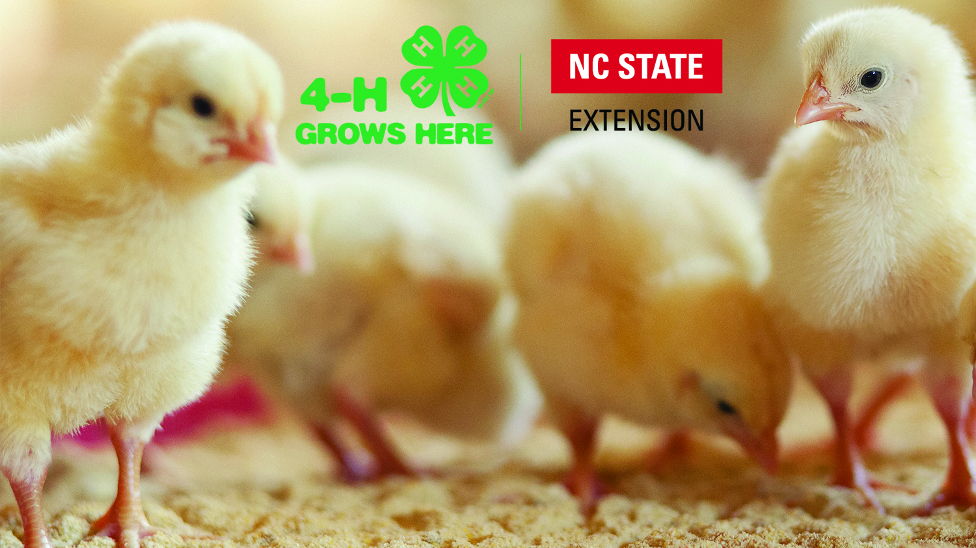
Poultry Events focus on poultry education and include poultry judging, NC State Fair Turkey Show, poster competition and a Poultry Science Summer Institute. https://poultry4hyouth.ces.ncsu.edu/ Contact: Mary Fosnaught, mhfosnau@ncsu.edu

4-H Electric Congress is an educational event that recognizes excellence in the NC 4-H Electric Program and rotates from each region of the state yearly. 4-H members participate in workshops, meet their Power Company Representatives, and interact with other electric winners. 4-H’ers must be at least 11 years old to attend. Counties may send up to seven 4-H’ers [2 county delegates (must complete an electric project record book), 2 portfolio delegates (must submit Electric portfolio), possibly 1 at-large portfolio delegate (10 in the state), 1 program recruiter and possibly 1 at-large program recruiter (10 in the state). 4-H Electric Congress is usually held in July and registration is due April 15. https://nc4h.ces.ncsu.edu/electric/ Contact: Grant Ellington, grant_ellington@ncsu.edu
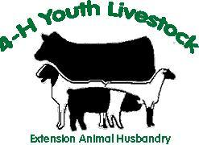
Livestock Events focus on livestock education and include graphic design contest (through NC Junior Beef Round-Up), livestock judging, livestock skill-a-thon, livestock quiz bowl, livestock shows and showmanship circuits, beef ambassador contest, and the Perry & Doris Teeter 4-H Beef Leadership Institute. https://youthlivestock.ces.ncsu.edu/ Contact: Brent Jennings, brent_jennings@ncsu.edu

Make It With Wool Competition This competition is open to ages listed below and all levels of sewing. Preteens: ages 5-12, Juniors: ages 13-16, Seniors: ages 17-24, Adults: age 25 and older.
Entries may be sewn, knitted, crocheted, woven or felted and must contain wool or wool blend (minimum 60% wool, mohair, cashmere, alpaca, camel, llama and/or vicuna). Contestants must select, construct and model the garment themselves. Entry deadline is in October and contest is in November.
Contact: Jean Thomas (704) 807-6683 Ejthom41@bellsouth.net

NC 4-H Congress is normally held in July, NC 4-H Congress is a four-day culminating event for the 4-H year. The event is geared for teen 4-H’ers ages 13-18. Congress is held on the campus of NC State University. Activities include state presentation finals, Honor Club tapping, state-level hands-to-service project, State 4-H Council officer elections, banquets, dances, engaging workshops, and more. Presentation contest happens on Saturday morning and Congress begins Saturday afternoon.https://nc4h.ces.ncsu.edu/youth-3/4-h-teen-programs/youth-congress/
Contact: Sarah Kotzian, sarah_kotzian@ncsu.edu
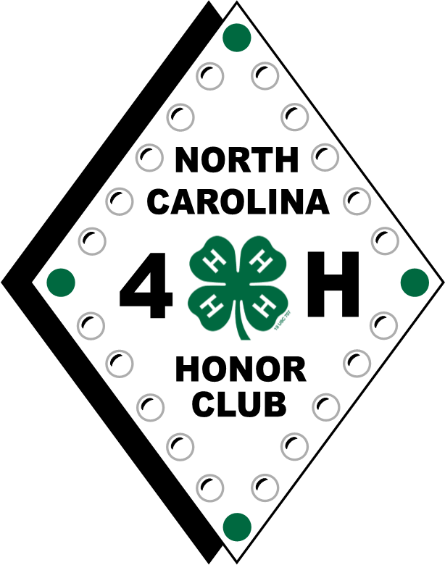
NC 4-H Honor Club 4-H’er must be at least 16 years old as of January 1 to apply. Membership is based on a point system involving community service, 4-H activities, leadership and citizenship. Applications due in the State 4-H Office by February 1. https://nc4h.ces.ncsu.edu/youth-3/4-h-teen-programs/nc-4-h-honor-club/
Contact: Shannon McCollum, shannon_mccollum@ncsu.edu

Shooting Sports Program strives to develop life skills through participation, learning, and competition in the shooting sports including rifle, shotgun, archery, muzzle loading, pistol, and hunting. The program is based in county clubs that can participate in competition and other learning activities on local, regional, state and national levels. https://nc4h.ces.ncsu.edu/youth-3/nc-4-h-shooting-sports-program/
Contact: Charles Young, Charles_Young@ncsu.edu

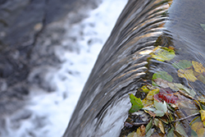
State Photo Contest The purpose of the state photo contest is to provide a showcase of 4-H members' photographic accomplishments. The exhibit is usually unveiled at 4-H Congress and winning photos are displayed at events throughout the year. Youth will utilize their skills and their artistry to capture their view of America and patriotism. https://nc4h.ces.ncsu.edu/youth-3/north-carolina-4-h-photo-contest/
Contact: Peggie Lewis Joyce, peggie_lewis@ncsu.edu

State 4-H Council Officers A 4-H member is eligible to run for State 4-H Office if he or she is at least 16 years of age as of January 1 of the year of nomination, and if he or she has been an active 4-H member for at least three years prior to seeking office. https://nc4h.ces.ncsu.edu/youth-3/4-h-teen-programs/state-council/
Contact: Mitzi Downing, mitzi_downing@ncsu.edu
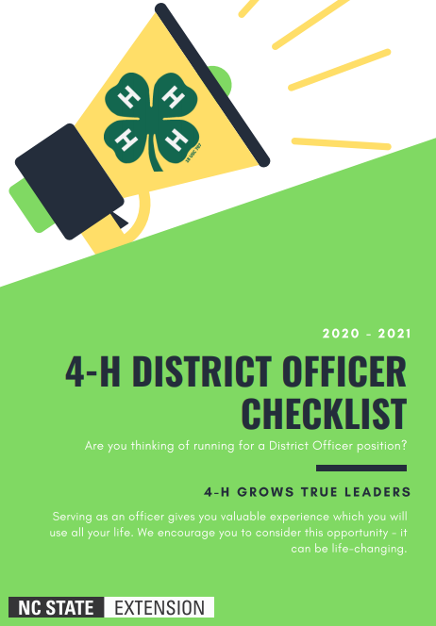
District 4-H Officers http://www.nc4 h.org/youth/statecouncil/ Candidates for district office must be at least 14 years old and have been an active 4-H member for at least two years. A person may only serve as a district officer once. Contact: Mitzi Downing, mitzi_downing@ncsu.edu and District Agent Advisors

Teen Retreats The NC State 4-H Program is divided into five districts: West, North Central, South Central, Northeast and Southeast. District officers from each district help plan their district-wide 4-H event held in the spring. Teen Retreat offers training and workshops centering on leadership, citizenship, and service learning for 4-H’ers ages 13 to 18. District teen council officers are elected either at Teen Retreat or District Activity Day, depending on the district. Contact: Mitzi Downing, mitzi_downing@ncsu.edu and District Agent Advisors

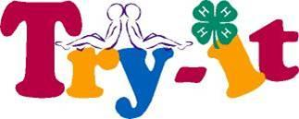
TRY (Teens Reaching Youth) provides an opportunity for 3-5 teen 4-H’ers and 1-2 adults to become certified members and teach younger youth about any topic that is important in your community as identified by your community leaders. https://nc4h.ces.ncsu.edu/youth-3/4-h-teen-programs/ Contact: Shannon McCollum, shannon_mccollum@ncsu.edu

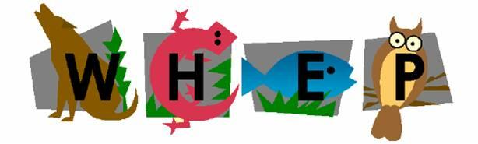
Forestry & Wildlife Program includes projects, presentations, and 2 contests [Wildlife Habitat Evaluation Program (WHEP) and 4-H Forestry Contest]. WHEP is a natural resource program dedicated to teaching wildlife and fisheries habitat management to junior and senior level youth and 4-H Forestry Contest helps youth develop appreciation for conserving forests. http://forestry.ces.ncsu.edu/4h/ Contact: Renee Strnad, renee_strnad@ncsu.edu

Youth Volunteer Awards for District and State are presented at NC 4-H Congress to individuals who have demonstrated outstanding leadership and volunteer service. http://www.nc4h.org/youth/4-h-teen-programs
Contact: Sarah Kotzian, sarah_kotzian@ncsu.edu

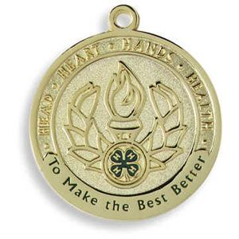
4-H Achievement Plan allows 4-H’ers to set goals, achieve goals, and evaluate efforts to accomplishments that they have achieved through 4-H. In this perpetual plan, service to others, creativity, responsibility, and leadership are important. This plan encompasses four achievement levels: green, bronze, silver, and gold.
Contact: Shannon McCollum, shannon_mccollum@ncsu.edu

County Activity Day is the county presentation competition that is held to determine who advances to District Activity Day in presentations. A talent showcase is also held to determine your county participants for 4-H Entertains (2 per county participate at district). Contact: Local 4-H Agent

Public Speaking Contest is the county competition to determine which 4-H’ers will advance to District Activity Day.
4-H’ers who win in both presentations and public speaking on the county level can only compete in one of these competitions at District Activity Day, NOT BOTH. Contact: Local 4-H Agent

County Council is comprised of officers from all 4-H Clubs in the county. County Council members help plan county events and keep their respective clubs informed of county events. Contact: Local 4-H Agent
Expressive Arts allows youth to prepare for entering artistic items in the local/state fairs and other 4-H state level contests. Contact: Local 4-H Agent

State Fair 4-H Opportunities The North Carolina State Fair provides 4-H’ers with a wonderful opportunity to market 4-H and their county by participating in 4-H Crafts, 4-H Photography, 4-H Hay Bale Decorating, 4-H Entomology and each Extension District with opportunities to exhibit their 4-H skills and talents. There are premium offered to the winners in each area. 4-H’ers must pre-register through the fair.
Contact: Shannon McCollum, shannon_mccollum@ncsu.edu

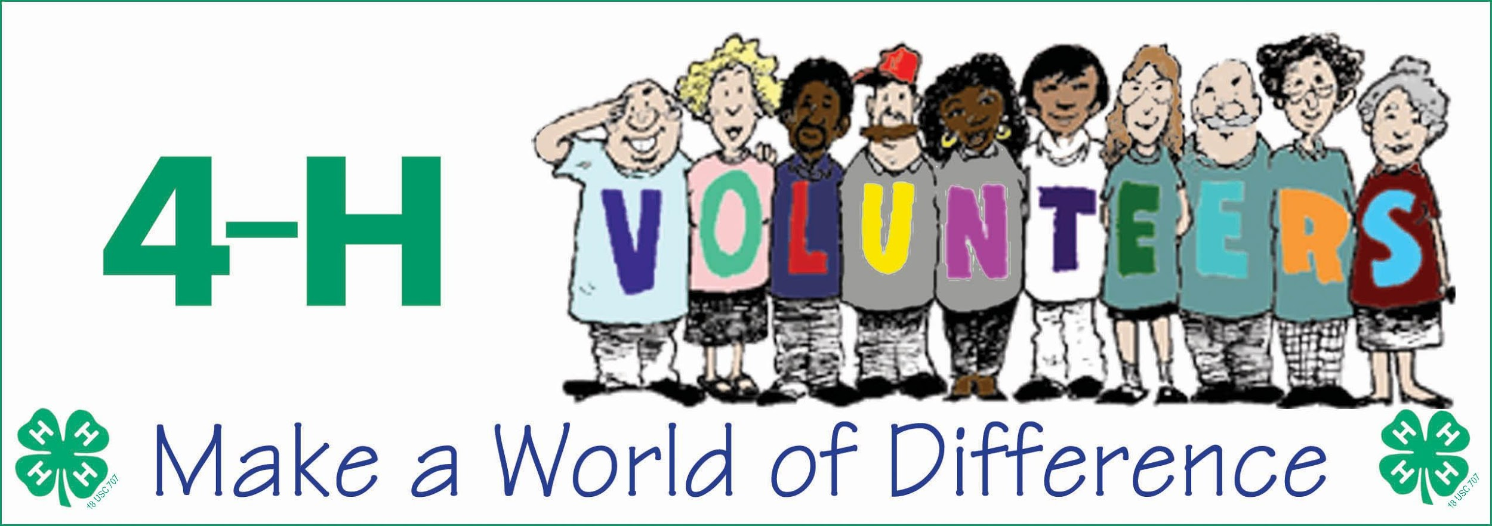

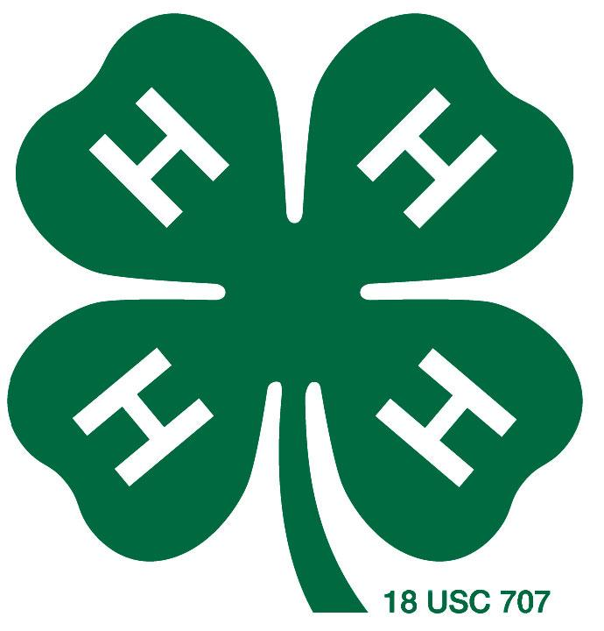
4-H Volunteer Opportunities

NC 4-H Volunteer Leaders’ Association (VLA) 4-H volunteers can participate in county, district and state leaders’ associations. VLA provides opportunities for county, district and state level trainings and the association offers scholarships for 4-H youth. There is also the potential for leadership development by serving as a county, district or state officer. https://nc4h.ces.ncsu.edu/nc4h-volunteers/ Contact: Sarah Kotzian, sarah_kotzian@ncsu.edu

NC 4-H Volunteer Leaders’ Conference is normally held in February and provides an opportunity for volunteer leaders to come together, participate in workshops and training, elect new State Association Officers, and recognize the accomplishments of 4-H Volunteers. https://nc4h.ces.ncsu.edu/nc4h-volunteers/
Contact: Sarah Kotzian, sarah_kotzian@ncsu.edu

Volunteer Conference of Southern States’ primary purpose is to educate and prepare volunteers to share the information acquired at the forum with their own 4-H programs and activities. Participants benefit from the experiential learning activities that require them to discuss, use, and apply what they learn. This event is held annually in October at Rock Eagle 4-H Center in Eatonton, Georgia. https://www.4hvcoss.com/
Contact: Harriett Edwards, harriett_edwards@ncsu.edu

Volunteer Leader Recognition NC 4-H Volunteer Leaders’ Association (VLA) annually sponsors a statewide volunteer recognition program to formally acknowledge the excellent work of these individuals who give their time, talents and resources in support of the youth participating in North Carolina 4-H programs. Nominations are typically due in December. http://www.nc4h.org/volunteers/
Contact: Sarah Kotzian, sarah_kotzian@ncsu.edu

This document was originally developed by 4-H Agents in North Carolina (updated May 26, 2020)

