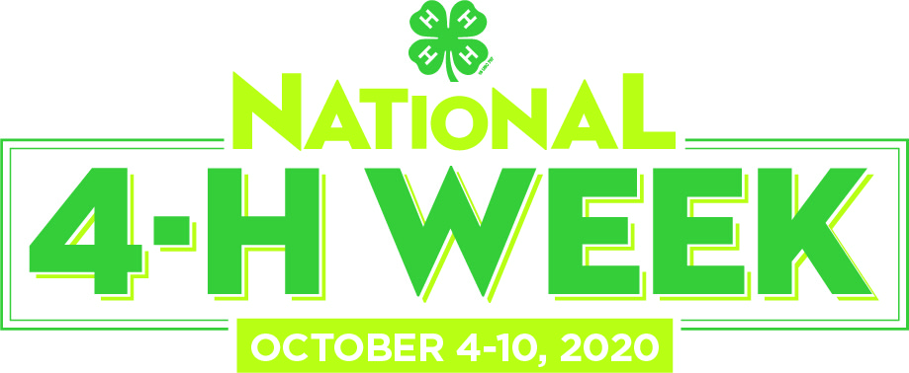

NATIONAL 4-H WEEK DECLARATION

WHEREAS, 4-H youth across the nation are leading efforts to solve problems in their communities and make a difference for their futures; and

WHEREAS, 4-H is the largest youth development organization in North Carolina and the largest in the nation with over six million participants; and

WHEREAS, 4-H in North Carolina claims 261,210 youth members and 16,789 volunteers, while Enter Your County Name Here 4-H program numbers more than Enter your county’s total number of 4-H members members and more than Enter your county’s total number of 4-H volunteers volunteers; and

WHEREAS, 4-H as part of the NC Cooperative Extension System of NC State University and NCA&T State University is a program where youth learn through opportunities that provide them hands-on experiences in 4-H’s mission mandates of science, engineering and technology; healthy living; and citizenship; and

WHEREAS, 4-H has connected youth and their communities with the innovative research and resources from our nation’s 106 land-grant universities and colleges for more than 101 years.

NOW, THEREFORE, the Ener your county’s name here Board of Commissioners, do hereby proclaim October 4-10, 2020, as National 4-H Week in Enter your county’s name here. We urge the people of this County to take advantage of the opportunity to become more aware of this special program that enhances our young people’s interests in their futures as part of Enter your county’s name here 4-H Youth Development and to join us in recognizing the unique partnership between our County and our State University System.
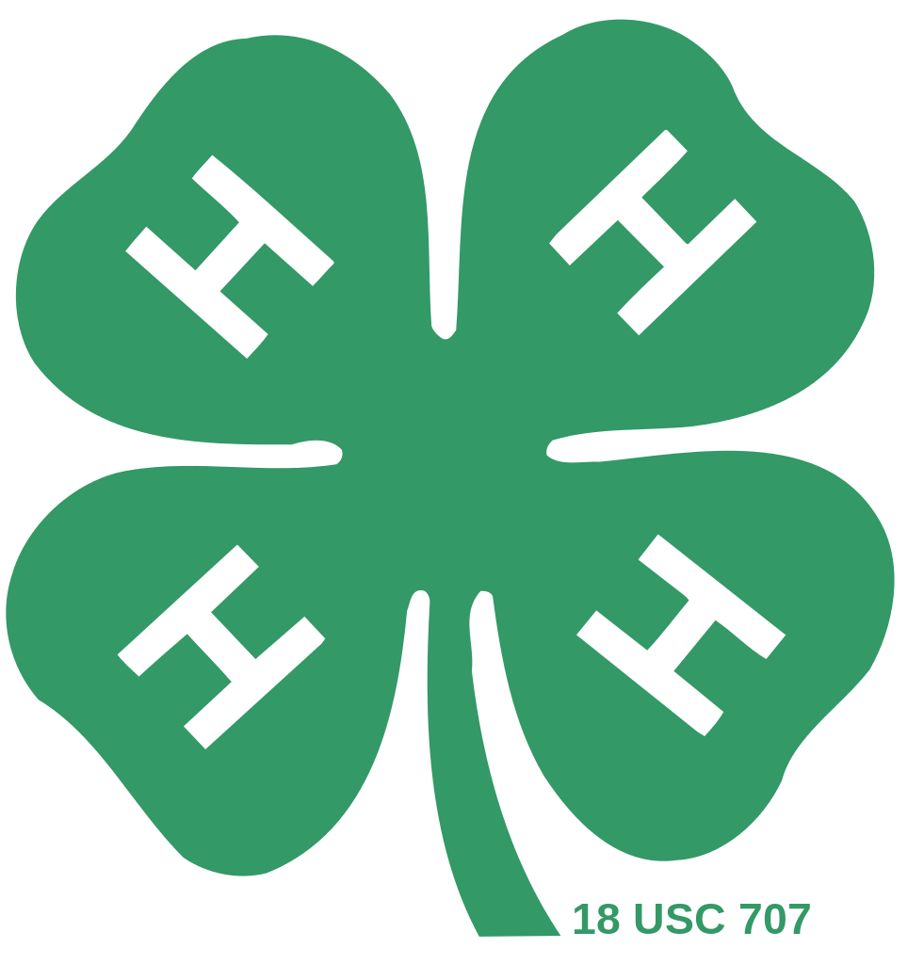
Adopted this the 1st day of October 2020.

____________________________________
Your County’s Chair of Commissioner Signature
County seal

