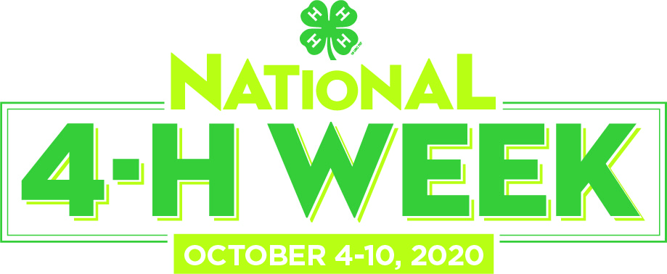

For Immediate Release

[Insert name of county] Youth to Celebrate
National 4-H Week October 4-10

City, North Carolina (Month, Day, Year) — The anticipation is building for National 4-H Week, during which millions of youth, parents, volunteers and alumni across the country will be celebrating everything 4-H. [Name of county] 4-H will observe National 4-H Week this year by showcasing the incredible experiences that 4-H offers young people, and will highlight the remarkable 4-H youth in our community who work each day to make a positive impact on those around them.

The theme of this year’s National 4-H Week is Opportunity4All, which highlights how 4-H encourages and embraces all kids to take part in hands-on learning experiences in areas such as health, science, agriculture and civic engagement. The positive environment provided by 4-H Professionals and Volunteers ensures that youth in every county in North Carolina and across the nation from urban neighborhoods to suburban schoolyards to rural farming communities ̶ are encouraged to take on proactive leadership roles and are empowered with the skills to lead in life and career.

[Insert a paragraph detailing how your program will be celebrating 4-H Week here]

“[Place quote from a local 4-H staff member about the value of the 4-H experience and how the youth have contributed to the community],” said [Individual's name and title]. "[Highlight a specific project and the effect it will have on the community]."

[Insert a paragraph highlighting the most popular and/or the newest 4-H programs offered in your county.]

In [name of county], more than [number] 4-H youth and [number] volunteers from the community are involved in 4-H.

One of the most anticipated events of National 4-H Week every year is 4-H National Youth Science Day, which sees hundreds of thousands of youth across the nation taking part in the world’s largest youth-led STEM challenge. The exciting theme for this year’s challenge is 4-H STEM Challenge, which will run throughout October. The 2020 4‑H STEM Challenge will explore sending a mission to Mars with the activity, Mars Base Camp. Developed by Google and Virginia Cooperative Extension, Mars Base Camp teaches kids ages 8-14 STEM skills like mechanical engineering, physics, computer science, and agriculture.

About 4-H:
4-H, the nation’s largest youth development and empowerment organization, cultivates confident kids who tackle the issues that matter most in their communities right now. In North Carolina, 4-H programs empower 261,210 youth members and 16,789 volunteers through the two land-grant universities (North Carolina State University and North Carolina Agricultural and Technical State University) and Cooperative Extension in all 100 counties plus the Qualla Boundary of the Cherokee Nation. Outside the United States, independent, country-led 4-H organizations empower one million young people in more than 50 countries.

To learn more about how you can get involved, visit nc4h.org find us on Facebook at https://www.facebook.com/NorthCarolina4H and on Twitter at North Carolina 4-H

###

Contact: [insert name], [insert title]
[insert telephone number], [insert Email address]

