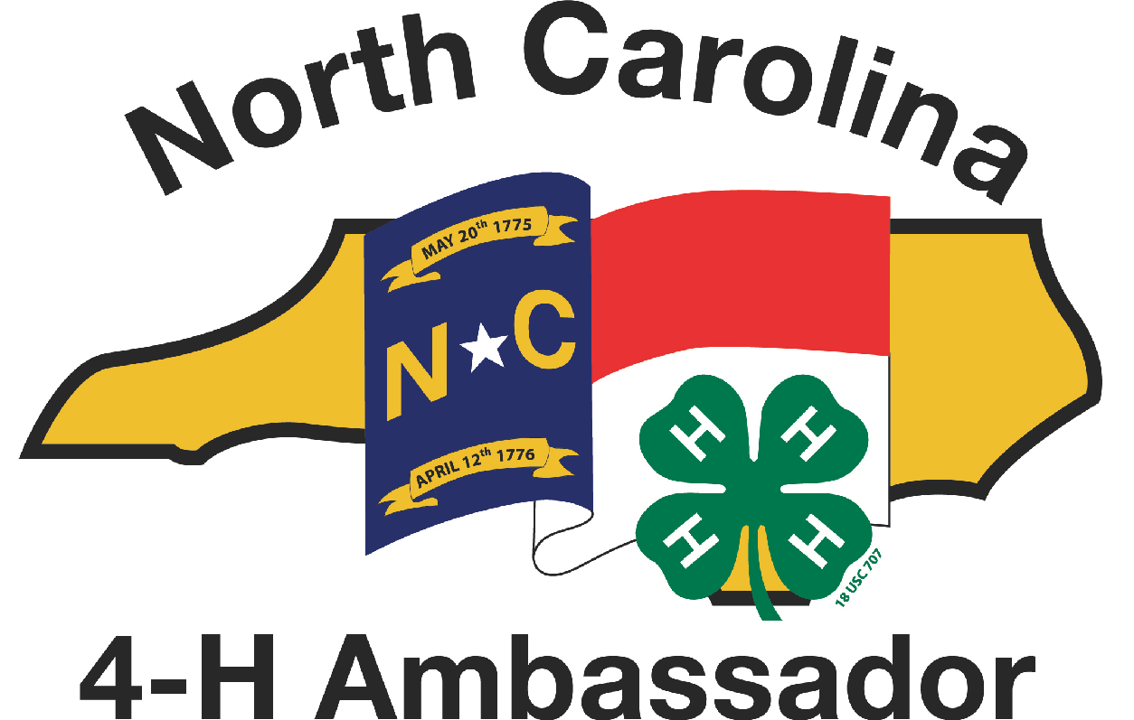
The North Carolina
4-H Ambassador Program

The mission of the North Carolina 4-H Ambassador program is to empower teen 4-H leaders with the knowledge, skills and aspirations necessary to be effective advocates for NC 4-H Youth Development. We strengthen and expand upon 4-H Ambassadors’ current leadership abilities so that they may serve as positive role models for younger youth; build meaningful partnerships with other teens and adult volunteer leaders and 4-H professionals; and promote the 4-H mission in North Carolina.

As NC 4-H Ambassadors, we value:
- gaining and utilizing new knowledge and skills that apply to both our 4-H work and other areas of our lives;
- developing individual and group leadership to their fullest potential;
- effective and meaningful partnerships with adult 4-H volunteers and professionals; and
- the maturity necessary to accept responsibility and fulfill our mission at the county, district and state levels.

Our vision is that every North Carolina teen 4-H member will have the personal initiative, program resources, and leadership opportunities to be a positive role model and a vocal advocate for the 4-H program in our state.

Basic Premises of the NC 4-H Ambassador Program
The NC 4-H Ambassador Program:
- Encourages personal development and service to NC 4-H for teen 4-H members.
- Is based upon an individual teen’s performance towards established standards.
- Is self-based and self-paced, i.e. an individual teen member pursues mastery of the required, elective and service components at their own pace, setting their own personal goals reflective of their individual situation.
- Documents the teen’s accomplishments through a Personal Leadership Portfolio developed by the Ambassador based upon defined criteria. Portfolios are reviewed and the teen’s accomplishments verified by county 4-H professionals, trained by state 4-H staff.

NC 4-H Ambassador Program Guidelines
- To apply to become a NC 4-H Ambassador, a member must be at least 13 years old and have been a 4-H member for 2 years, both as of January 1.
- Ambassador registrations must be handled by the county 4-H professional.
- It is recommended that a 4-H member take no longer than 2 calendar years to complete a single Ambassador level.
- A 4-H member must complete and have verified the requirements for each Ambassador level before moving on to the next level.
- Personal Leadership Portfolios will include both materials and personal reflections, and must follow the established statewide guidelines.
- A trained county 4-H professional and an adult volunteer and/or current Ambassador will review Portfolios and verify level requirements.
- Porfolios of members applying for each Ambassador level must be submitted to the State 4-H Office no later than June 15 and November 15 of the current year.
- All Ambassadors successfully completing any Ambassador level(s) will be recognized at the NC 4-H Congress.
- Ambassador required classes are taught by trained Youth Development Professionals, trained Volunteers and Ambassador Emerald Level Graduates. Check with your 4-H Agent.
- Training can be completed in the county by these trained professionals except for the Introduction to Ambassador Classes. This class is taught at the state or district level and by an approved person.

For more information please contact:

April B. Dillon

Area Extension Agent
4-H Youth Development

abdillon@ncsu.edu

(828) 766-0699
The NC 4-H Ambassadors Program Structure
Each LEVEL includes
Required Curricula | A minimum number of hours of Elective Activity  (You must participate in at least 2 different activities to achieve your required total hours per level)
Bronze
Recognition: Ambassador Name Tag & Certificate
Required Curricula | 15 Elective Hours of Activity
- Intro to the Ambassador Program*must be given by an “approved instructor”  - Fundamentals of 4-H Youth Development  - Public Speaking Basics  - Parliamentary Procedure  - Personal & Flag Etiquette | Suggestions include:  - Serve as a 4-H club and/or County Council officer  - Help plan a county event/workshop  - Create a 4-H exhibit/display/fair booth  - Attend a local government meeting  - Present a 4-H Presentation at the local/county level
Silver
Recognition: Ambassador Portfolio & Certificate
Required Curricula | 25 Additional Elective Hours
- Introduction to Life Skills  - Teaching & Learning I: Experiential Learning  - Advanced Public Speaking  - Leadership I: What is a Leader?  - Marketing I: Media Relations | Suggestions include:  - Attend a district retreat/workshop/meeting  - Help plan a district event  - Run for a district 4-H office  - Serve as a district 4-H officer candidate campaign manager  - 4-H presentation to non-4-H group, or at District Activity Day  - Plan & teach an educational program  - Meet with a county government official  - Mentor a Bronze Level Ambassador  - Serve on a TRY-IT! Team
Gold
Recognition: Ambassador Business Cards & Certificate
Required Curricula | 35 Additional Elective Hours
- Youth/Adult Partnerships I:  - Teaching & Learning II: Learning Styles  - Leadership II: Teamwork.  - Marketing II: Donors & Elected Officials  - Diversity & Inclusion | Suggestions include:  - Attend 4-H Congress or a state 4-H retreat  - Plan a state level 4-H event  - Teach a district/state workshop  - Participate in a 4-H Development Fund initiative  - Visit with a NC Legislator  - Do a 4-H presentation at the state level  - Serve on a county/district Extension/4-H board/advisory committee  - Participate in the A.I.R.E. program  - Serve as a judge at a 4-H event  - Serve as a state 4-H officer candidate campaign manager
Emerald
Recognition: Ambassador Polo Shirt & Certificate
Required Curricula | 45 Additional Elective Hours
- Youth/Adult Partnerships II: Youth in Governance  - Teaching & Learning III: Teaching Practicum  - Leadership III: The Role of Ethics  - Marketing Practicum Project | Suggestions include:  - Attend a national 4-H sponsored event  - Run for a state 4-H office  - Serve on a state/national 4-H committee/task force  - Teach a required 4-H Ambassador curriculum

Total Hours of Electives All Levels: 120

