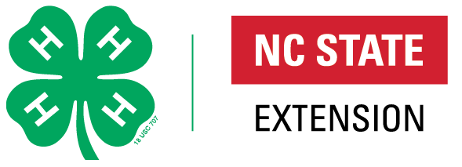
4-H CERTIFICATE ORDER FORM

COUNTY: __________________________ DATE: __________

AGENT: __________________________ DATE NEEDED: __________

Please fax this order form to Sarah Williams at (919)515-3483 or email this form to snwill13@ncsu.edu

Please check your supplies in advance to allow ample time to receive your order. Some certificates are hand signed so we need plenty of time to fill your order.

Some certificates are available for you to download by going to a google drive link shared below. You will need to download these to your computer. You can use Adobe Acrobat to type in them. Those are listed “Google Drive” in the Quantity column. Several others will have to mail to you as they require signatures.

https://golinks.ncsu.edu/4-hcertificates 4-H Certificate Download Link
https://nc4h.ces.ncsu.edu/4-h-club-charter/ - 4-H Charter Ordering Information Link

Award | Quantity | Mailed (State 4-H Office list)
Club Certificates
4-H Club Charter – new process - https://nc4h.ces.ncsu.edu/4-h-club-charter/

Gold Club Charter Seal
Emerald Club Charter Seal
Community Service Award
4-H Member Certificates
Certificate of Achievement | Google Drive
County Champion | Google Drive
Teen Leadership | Google Drive
Achievement Plan CloverBud 5-6 | Google Drive
Achievement Plan CloverBud 7-8 | Google Drive
Achievement Plan Green | Google Drive
Achievement Plan Silver | Google Drive
Achievement Plan Bronze | Google Drive
Achievement Plan Achievement Medal (county orders directly from National
4-H Youth Volunteer Award | Google Drive
School Enrichment | Google Drive
Adult Leader Certificates
4-H Adult Volunteer Award | Google Drive
Certificate of Appreciation

Contact Information: Shannon McCollum, Ed.D Extension Associate, 4-H Youth Development Specialist. Email: shannon_mccollum@ncsu.edu or by calling (919)515-8486.

