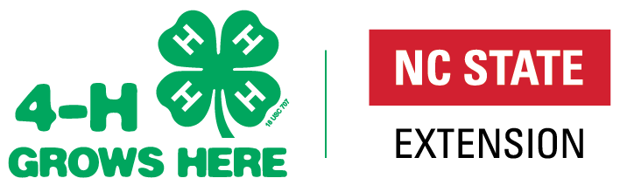

North Carolina 4-H Opportunities

For more information on NC 4-H go to: North Carolina 4-H | NC State Extension
All of the opportunities below require that youth, and adult volunteers be enrolled and active in 4-H Online. Additionally, all events operate under the 4-H Code of Conduct.

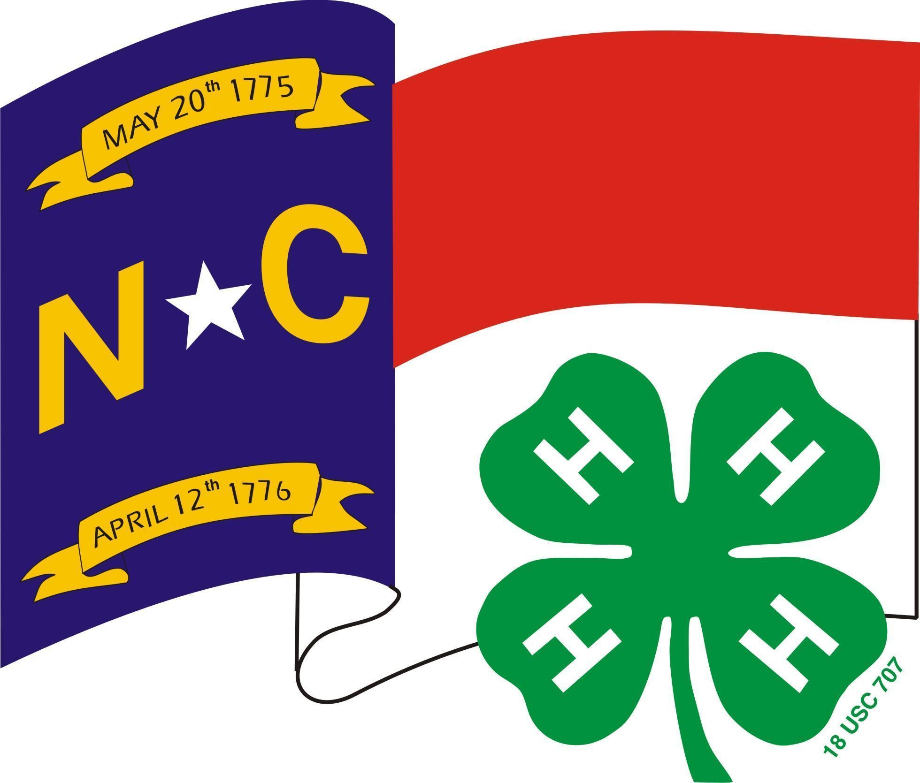
4-H Clubs are a great way to support long-term youth development and build community amongst our youth while instilling essential life skills such as leadership, commitment, and nurturing relationships. Whether they are working together on projects in Science & Technology or focusing their club efforts on environmental awareness, 4-H Club youth learn the importance of becoming engaged in the community, country, and world. 4-H Clubs must consist of at least 5 youth from 3 different families. Youth ages 5-18 may be club members, but clubs may have specific age ranges. Contact your local 4-H Staff for county opportunities. North Carolina 4-H Clubs | NC State Extension State Contact: Shannon McCollum, shannon_mccollum@ncsu.edu

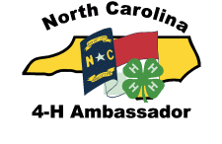
4-H Ambassadors Applicants must be at least 13 years old and a 4-H member for two years as of January 1. 4-H’ers may earn Bronze, Silver, Gold, and Emerald Ambassador levels by completing workshops and a portfolio for each level. This program strengthens and expands upon 4-H Ambassadors' current leadership abilities and allows them to serve as positive role models for younger youth. Contact your local 4-H Staff for county opportunities. North Carolina 4-H Ambassador Program | NC State Extension State Contact: April Dillon, april_dillon@ncsu.edu

College Scholarships High school seniors may apply for NC 4-H scholarships. The electronic application is due to the State 4-H Office by February 1 and must be signed by your 4-H Staff so check with them for their deadline. The application will allow youth to apply for one or more scholarships. PLEASE note that several scholarships are restricted, and youth MUST meet certain criteria to apply so read the scholarship guide closely. Scholarship awards range in amounts from $500 to $2,000. Contact your local 4-H Staff for county opportunities. 4-H Awards & Incentives Programs | NC State Extension State Contact: Shannon McCollum, shannon_mccollum@ncsu.edu

4-H Group Awards that 4-H clubs/groups/counties can apply for each year: The NC 4-H Community Service award (based on community service projects completed by a 4-H club/group) and The 4-H Electric Group Award (based on electric programming completed by the county as a whole or an individual 4-H club/group). One application per county is eligible for State Competition in each of these awards. Applications must be received by the State 4-H Office by March 1.
Contact your local 4-H Staff for county opportunities. 4-H Awards & Incentives Programs | NC State Extension
State Contact: Shannon McCollum, shannon_mccollum@ncsu.edu

4-H Project Records highlights what 4-H’ers have learned and done in a specific project area for a period of 12 months. The books are judged by subject and age categories (8-10, 11-12, 13-15 and 16-18), Cloverbuds (ages 5-7) may also turn in a project record book, but these books are not judged competitively. Project Record books are due in the County 4-H office for judging by the county deadline. The top two county winners in each curriculum area advance to Raleigh for district competition. Age for Project Record competition is based on 4-H’ers age as of Jan 1 of the year the project work is completed. Books must be received in the State 4-H Office by March 1. Contact your local 4-H Staff for county opportunities and deadlines. 4-H Awards & Incentives Programs | NC State Extension
State Contact: Shannon McCollum, shannon_mccollum@ncsu.edu

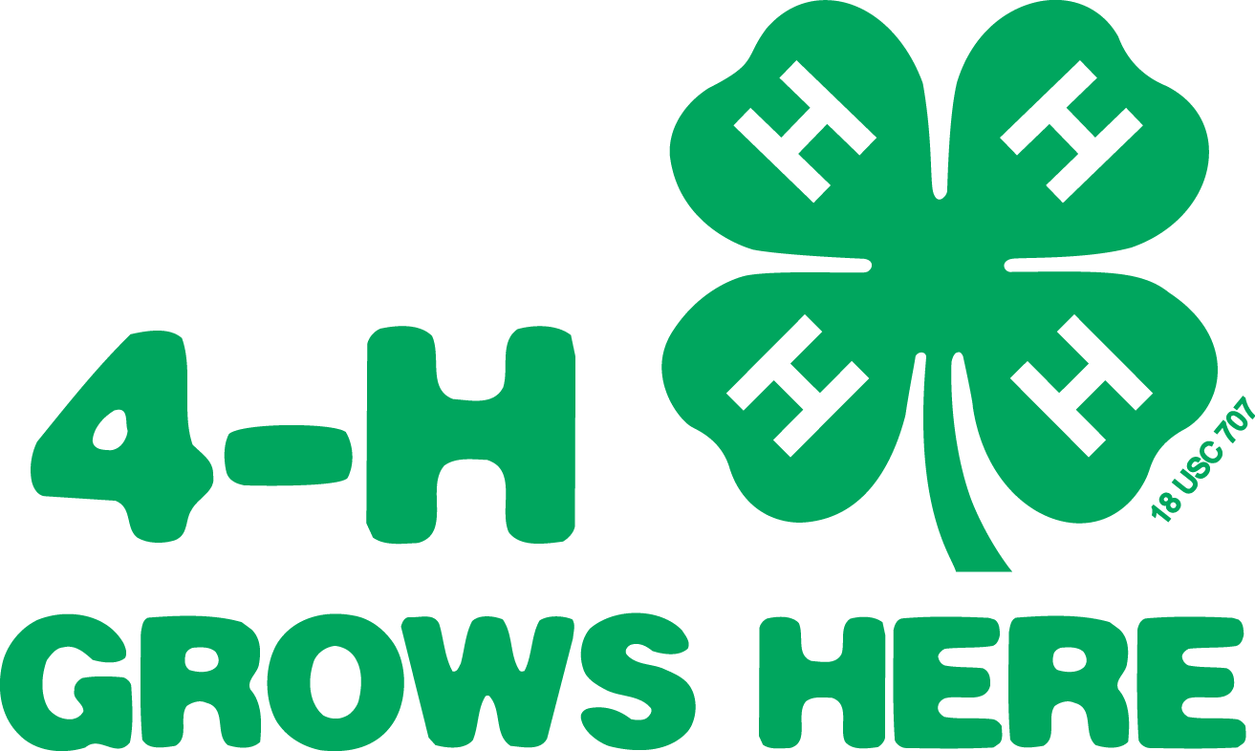
4-H Portfolios are a 3-year accumulation of 4-H project work in a major project area in age categories of 13-15 and 16-18 (age as of Jan. 1 for the last year of work that you are including in this portfolio). Portfolios are due in the State 4-H Office by March 1, so counties will have a deadline prior to this. State winners receive cash awards depending on the availability of funds. Contact your local 4-H Staff for county opportunities. 4-H Awards & Incentives Programs | NC State Extension
State Contact: Shannon McCollum, shannon_mccollum@ncsu.edu

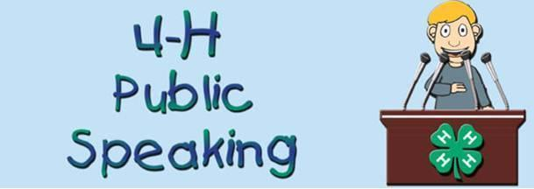
4-H Presentations and Public Speaking allow youth the opportunity to present information by demonstration or illustrated talk for competition. Presentations are judged by subject and age categories (8-10, 11-13, 14-18), Cloverbuds (ages 5-7) may also do presentations, but cannot compete. The time limit is generally between 5 and 12 minutes, with specific time regulations in specific categories. The competition typically begins at the county level and each county may send two presentations in each age category for every subject to the district competition. The Gold winner in all three age categories and the silver winner in the 11-18-year-old categories advance to the state competition. The winners of some categories advance to national. Contact your local 4-H Staff for county opportunities. Presentations | NC State Extension
State Contact: Shannon McCollum, shannon_mccollum@ncsu.edu

Application, Interview, Resume and Essay (AIRE) is due in State 4-H Office May 15. Applicants must be at least 14 years old as of January 1. This program is used to select the delegations to attend National 4-H Congress, National 4-H Conference, and the International Leadership Conference. Participants must complete a two-page application and submit a resume of no more than two pages and an Essay on the theme assigned for that year. The resume should highlight the 4-H’ers achievements, project work, and leadership throughout their career. The County 4-H Staff must sign off on the application before it is submitted prior to the deadline. Interviews are held virtually. Contact your local 4-H Staff for county opportunities. AIRE (Application, Interview, Resume & Electronic-Video) | NC State Extension
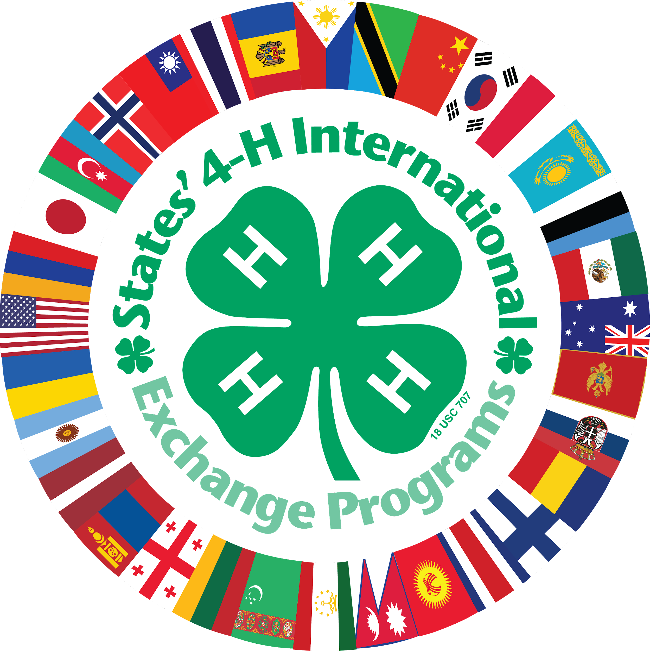
State Contact: Mitzi Downing, mitzi_downing@ncsu.edu

4-H International Programs is designed for 4-H youth who want the experience of another culture and to gain a global perspective. Youth must be at least 4-H Age 17 for outbound exchanges and not over 21 years of age. Families with youth ages 10-18 may apply to host an inbound student. Contact your local 4-H Staff for county opportunities. NC 4-H International Exchange Programs | NC State Extension
State Contact: Shannon McCollum, shannon_mccollum@ncsu.edu

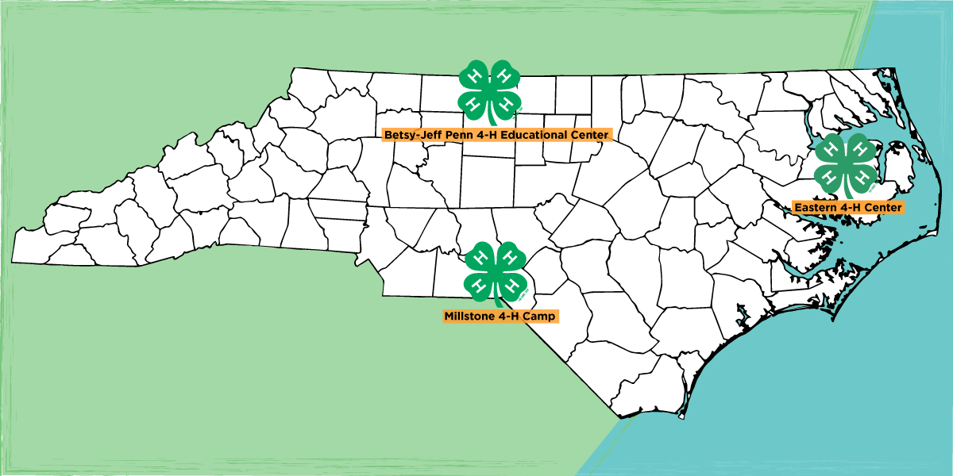
4-H CAMPS offer excellent overnight and day camp opportunities for youth 6-17 at three NC 4-H Centers (Betsy-Jeff Penn, The Eastern Center, and Millstone). Counties may elect to take a group of youth (ages 8-14) to a week of “traditional 4-H camp”, but youth may also register through open enrollment if they desire to attend another week. (space is limited) The number of 4-H camp sessions and dates are announced the year before so that 4-H Staffs can arrange “multiple county camping groups” if desired. 4-H “Specialty Camps” are also offered and built around a theme (Cloverbud, Marine Science & Sailing, Fur, Fish & Game Rendezvous, Horsemanship Camp, etc.). Opportunities are available for older youth (ages 15-17) to serve as a LIT (Leader in Training). 4-H Camp Staff opportunities are those individuals age 18+). Contact your local 4-H Staff for county opportunities. North Carolina 4-H Camps and Centers State Contacts: David Herpy, djherpy@ncsu.edu and Angela Brisson, aebrisso@ncsu.edu

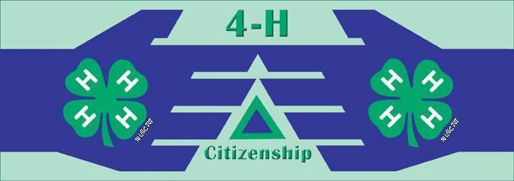
Citizenship NC Focus Spend three days at our state capital participating in hands-on workshops, panel discussions, distinguished speakers and open discussion to discover how government impacts your everyday life, and how you can impact government in return. 4-H’ers will learn about state government, learn about working with public officials, hear from prominent NC officials, and visit legislators.Contact your local 4-H Staff for county opportunities.
4-H Citizenship NC Focus | NC State Extension State Contact: Sarah Kotzian, sarah_kotzian@ncsu.edu

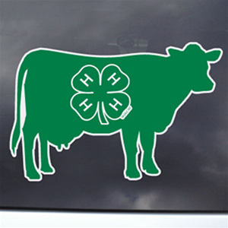
Dairy Events focus on dairy education and include dairy judging, dairy quiz bowl, dairy skill-a-thon, dairy photo contest, numerous dairy shows, and national 4-H dairy conference. Contact your local 4-H Staff for county opportunities. Dairy Youth Programs | NC State Extension
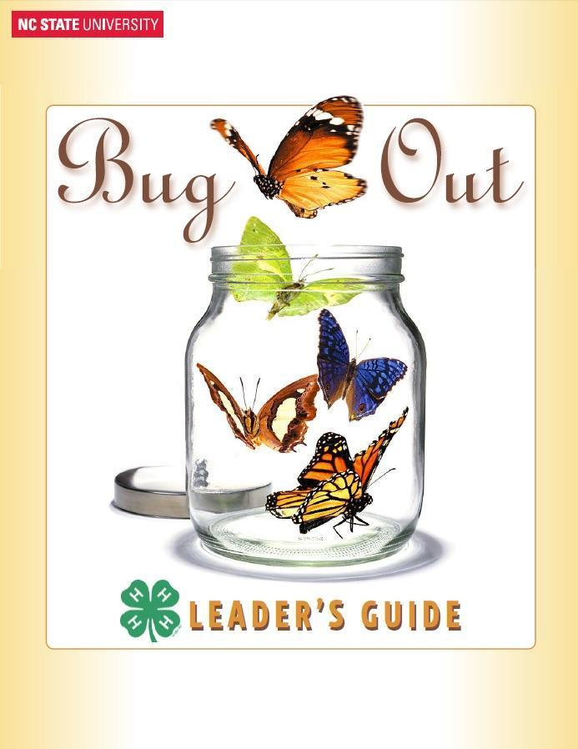
State Contact: Stephanie Ward, shward@ncsu.edu

Entomology Events focus on Entomology education and include presentations, Beekeeping Essay, insect collections. Contact your local 4-H Staff for county opportunities. Entomology Events | NC State Extension State Contact: Liz Driscoll, liz_driscoll@ncsu.edu
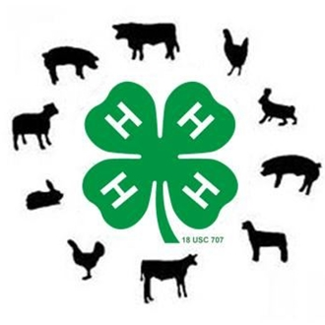
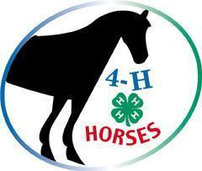
Livestock Events focus on livestock education and include graphic design contest (through NC Junior Beef Round-Up), livestock judging, livestock skill-a-thon, livestock quiz bowl, livestock shows and showmanship circuits, beef ambassador contest, and Leadership training. Contact your local 4-H Staff for county opportunities. Youth Livestock Program | NC State Extension
State Contact: Brent Jennings, brent_jennings@ncsu.edu

Horse Events focus on horse education and include Equine Expressive Arts Contests, Horse Bowl, Hippology, Retreats, Horse Judging, Horse Shows, and Horsemanship Camp. Contact your local 4-H Staff for county opportunities. NC 4-H Horse Program | NC State Extension State Contact: Alaina Cross, alaina_cross@ncsu.edu

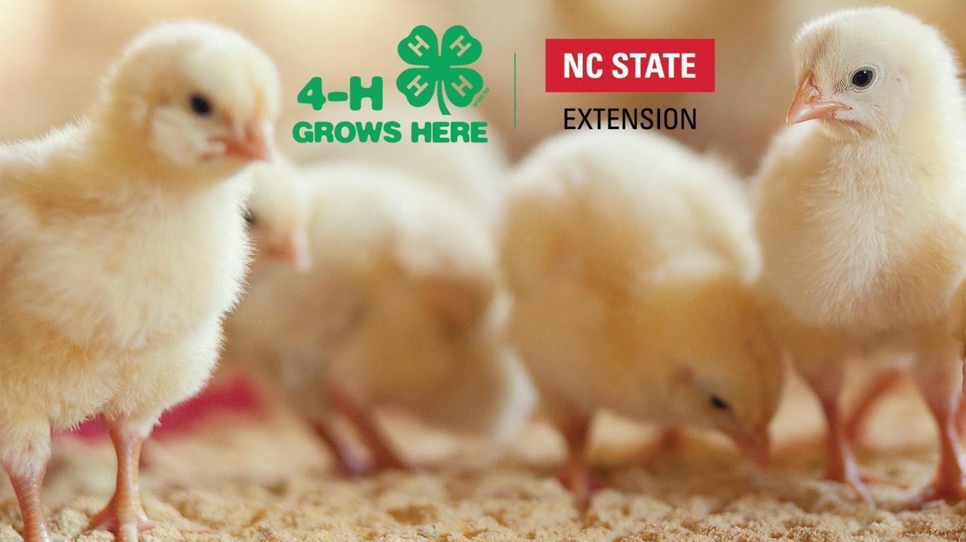
Poultry Events focus on poultry education and include poultry judging, NC State Fair Turkey Show, poster competition, and the Poultry Science Summer Institute. Contact your local 4-H Staff for county opportunities. Poultry 4-H & Youth | NC State Extension
State Contact: Mary Fosnaught, mhfosnau@ncsu.edu

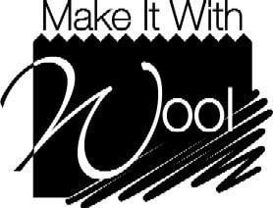
Make It With Wool Competition This competition is open to ages listed below and all levels of sewing. Preteens: ages 5-12, Juniors: ages 13-16, Seniors: ages 17-24, Adults: age 25 and older.
Entries may be sewn, knitted, crocheted, woven or felted and must contain wool or wool blend (minimum 60% wool, mohair, cashmere, alpaca, camel, llama and/or vicuna). Contestants must select, construct and model the garment themselves. Entry deadline is in October and contest is in November.
NC Make It With Wool - Home State Contact: Jean Thomas (704) 807-6683 Ejthom41@bellsouth.net

4-H Entertains is a talent showcase that typically occurs first at the county level, where two acts are selected to perform in conjunction with District Activity Day (DAD). Acts will then be selected to perform at the state talent show at 4-H Congress in July. This is for youth ages 8-18. Contact your local 4-H Staff for county opportunities.
Presentation Guidelines: 4-H Entertains | NC State Extension State Contact: Mark Dearmon, mark_dearmon@ncsu.edu

4-H District Activity Day 4-H’ers advancing from the county level presentation, public speaking, and clothing construction (if applicable will be coordinated by a district contact) contests are able to compete on the district level at District Activity Day. The top winners in presentations and public speaking can compete at the state level contest during 4-H Congress. State winners in sponsored categories receive cash awards. In specific categories, the state-winning seniors may go on to compete at the national level. Contact your local 4-H Staff for county opportunities.
State Contact: Shannon McCollum, shannon_mccollum@ncsu.edu

4-H Electric Congress is an educational event usually held in July that recognizes excellence in the NC 4-H Electric Program and rotates to different regions of the state annually. 4-H members participate in workshops, meet their Power Company Representatives, and interact with other electric winners. 4-H’ers must be at least 11 years old to attend. Counties may send up to seven 4-H’ers [2 county delegates ( the top two electric project record books), 2 portfolio delegates, and a recruiter. Counties may possibly send 2 more delegates. One at-large portfolio delegate (10 in the state) and one at-large program recruiter (10 in the state). Registration is due April 15. Contact your local 4-H Staff for county opportunities. 4-H Electric Program | NC State Extension State Contact: Grant Ellington, grant_ellington@ncsu.edu
NC 4-H Congress is a four-day culminating event for the 4-H year, normally held in July. The event is geared for teen 4-H’ers ages 13-18 and is held on the campus of NC State University. Activities include state presentation finals, Honor Club tapping, state-level hands-to-service project, State 4-H Council officer elections, banquets, dances, engaging workshops, and more. The state presentation contest happens on Saturday morning and Congress begins Saturday afternoon. Youth Congress | NC State Extension State Contact: Sarah Kotzian, sarah_kotzian@ncsu.edu
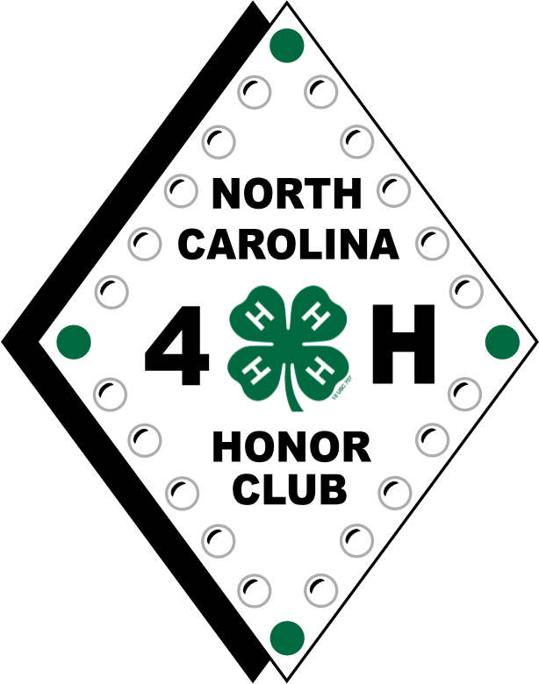
NC 4-H Honor Club 4-H’er must be at least 16 years old as of January 1 to apply. Membership is based on a point system involving community service, 4-H activities, leadership and citizenship. Applications are due in the State 4-H Office by February 1, so check with your county staff about their deadline.
NC 4-H Honor Club | NC State Extension State Contact: Shannon McCollum, shannon_mccollum@ncsu.edu

Shooting Sports Program strives to develop life skills through participation, learning, and competition in the shooting sports including rifle, shotgun, archery, muzzle loading, pistol, and hunting. The program is based in county clubs utilizing volunteers that have trained throug the NC 4-H Shooting Sports Program in April or October. Club members can participate in competition and other learning activities on local, regional, state and national levels. Contact your local 4-H Staff for county opportunities. NC 4-H Shooting Sports Program | NC State Extension
State Contact: Charles Young, charles_young@ncsu.edu

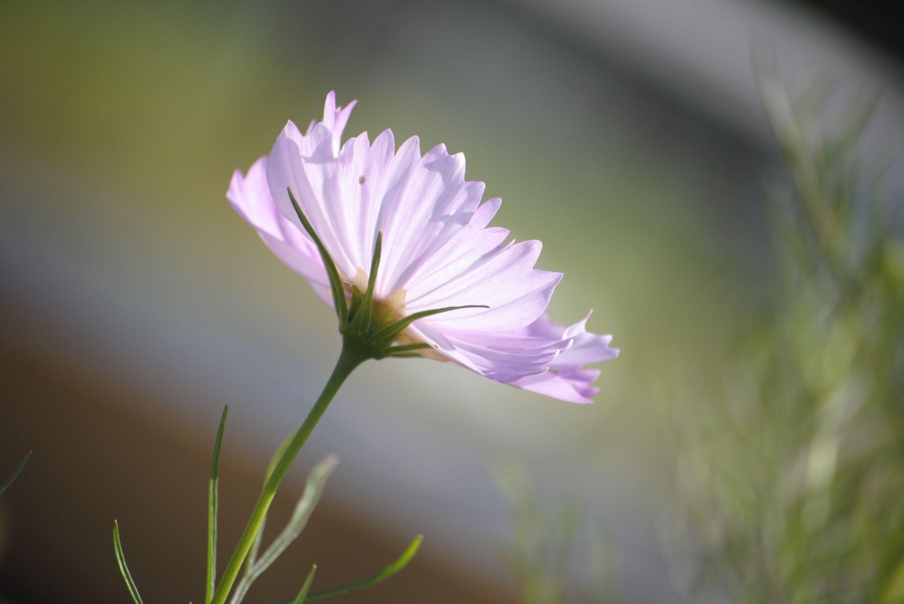
State Photo Contest The purpose of the state photo contest is to provide a showcase of 4-H members' photographic accomplishments. The exhibit is unveiled during National 4-H Week and winning photos are displayed on the photography contest website. Youth will utilize their skills and their artistry to capture their view of the three subject categories. 4-H in Action and Nature’s Bueaty are two of the annual categories. The third category changes annually. Contact your local 4-H Staff for county opportunities. North Carolina 4-H Photo Contest | NC State Extension
State Contact: Peggie Lewis Joyce, peggie_lewis@ncsu.edu

State 4-H Council Officers A 4-H member is eligible to run for State 4-H Office if he or she is at least 16 years of age as of January 1 of the year of nomination, and if he or she has been an active 4-H member for at least three years prior to seeking office. State officer candidates must have served as a district officer. State 4-H Council | NC State Extension
State Contact: Mitzi Downing, mitzi_downing@ncsu.edu
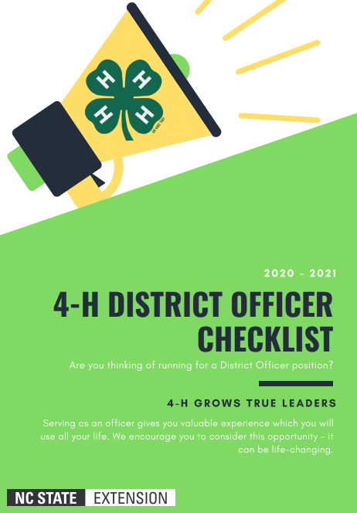
District 4-H Officers Candidates for district office must be at least 14 years old and have been an active 4-H member for at least two years. A person may only serve as a district officer once. Officer positions include: President, Vice-President, Secretary/Treasurer, and Reporter. State 4-H Council | NC State Extension
State Contact: Mitzi Downing, mitzi_downing@ncsu.edu and District Staff Advisors

Teen Retreats The NC State 4-H Program is divided into five districts: West, North Central, South Central, Northeast and Southeast. District officers from each district help plan their district-wide 4-H event held in the spring. Teen Retreat offers training and workshops centering on leadership, citizenship, and service learning for 4-H’ers ages 13 to 18. District teen council officers are elected either at Teen Retreat or District Activity Day, depending on the district. Some districts also host a Fall or Winter Day/Retreat.Contact your local 4-H Staff for county opportunities.
State Contact: Mitzi Downing, mitzi_downing@ncsu.edu and District Staff Advisors

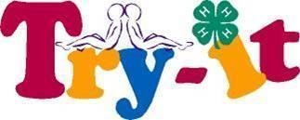
TRY (Teens Reaching Youth) provides an opportunity for 3-5 teen 4-H’ers and 1-2 adults to become certified members and teach younger youth about any topic that is important in your community as identified by your community leaders. 4-H Teen Programs | NC State Extension
State Contact: Peggie Lewis Joyce, peggie_lewis@ncsu.edu

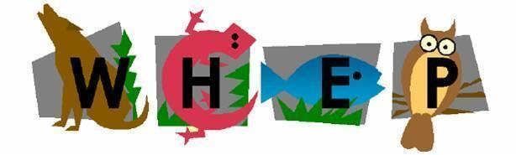
Forestry & Wildlife Program includes projects, presentations, and 2 contests [Wildlife Habitat Evaluation Program (WHEP) and 4-H Forestry Contest]. WHEP is a natural resource program dedicated to teaching wildlife and fisheries habitat management to youth and the 4-H Forestry Contest helps youth develop appreciation for conserving forests. Contact your local 4-H Staff for county opportunities. http://forestry.ces.ncsu.edu/4h/ State Contact: Renee Strnad, renee_strnad@ncsu.edu

Youth Volunteer Awards for District and State are presented at NC 4-H Congress to individuals who provided exemplary service to their communities during the previous year. Contact your local 4-H Staff for county opportunities.
North Carolina 4-H Youth Volunteer Award Nominations State Contact: Sarah Kotzian, sarah_kotzian@ncsu.edu

Creating and Piloting Curriculum. Each year, content specialists take cutting edge research and turn it into relatable curriculum for use in schools, afterschool programs, camps, and other non-formal education settings. Curriculum content themes include Leadership/Citizenship, Agriculture/Livestock, Health/Life Skills, STEM, etc. Opportunities exist for Staffs, volunteers, educational partners, and youth to participate in creating and piloting curricula. Each curriculum is built using a content specialist, an advisory team, and an evaluation specialist to make sure it meets rigorous standards to meet the needs of K-12 partners and 4-H. Curricula provides the content from which 4-H programs are developed. Curriculum Overview | NC State Extension State Contact: Amy Chilcote, amy_chilcote@ncsu.edu

4-H County Opportunities

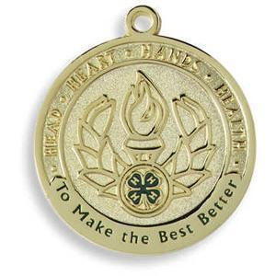
4-H Achievement Plan allows 4-H’ers to set goals, achieve goals, and evaluate efforts to accomplishments that they have achieved through 4-H. In this perpetual plan, service to others, creativity, responsibility, and leadership are important. This plan encompasses four achievement levels: green, bronze, silver, and gold.
Contact: Local 4-H Staff

County Activity Day is the county presentation and public speaking competition that is held to determine who advances to District Activity Day in presentations. Only two youth or teams may advance in each age category and project area. A talent showcase is also held to determine the county participants for 4-H Entertains (2 per county participate at district). Contact: Local 4-H Staff

County Council members are usually older youth that help plan county events, serve in leadership roles, and on planning committees. They also help keep their respective clubs informed of county events. Contact: Local 4-H Staff
Expressive Arts such as crafts, sewing, etc. allows youth to prepare for entering artistic items in the local/state fairs and other 4-H state level contests. Contact: Local 4-H Staff

State Fair 4-H Opportunities The North Carolina State Fair provides 4-H’ers with a wonderful opportunity to market 4-H and their county by participating in 4-H Crafts, 4-H Photography,, 4-H Entomology and more. Each county may enter one decorated hay bale, and each Extension District enters one 4-H fair booth (on a rotation schedule). There are premiums offered to the winners in each area. 4-H’ers must pre-register through the fair’s website under the competitive entries tab. Contact your local 4-H Staff for county opportunities. Welcome to the North Carolina State Fairgrounds
State Contact: Shannon McCollum, shannon_mccollum@ncsu.edu

Additional Opportunities Every county has unique opportunities for fundraising, marketing, teaching, and leadership. Contact your county 4-H Staff for additional information. Find Your County Center

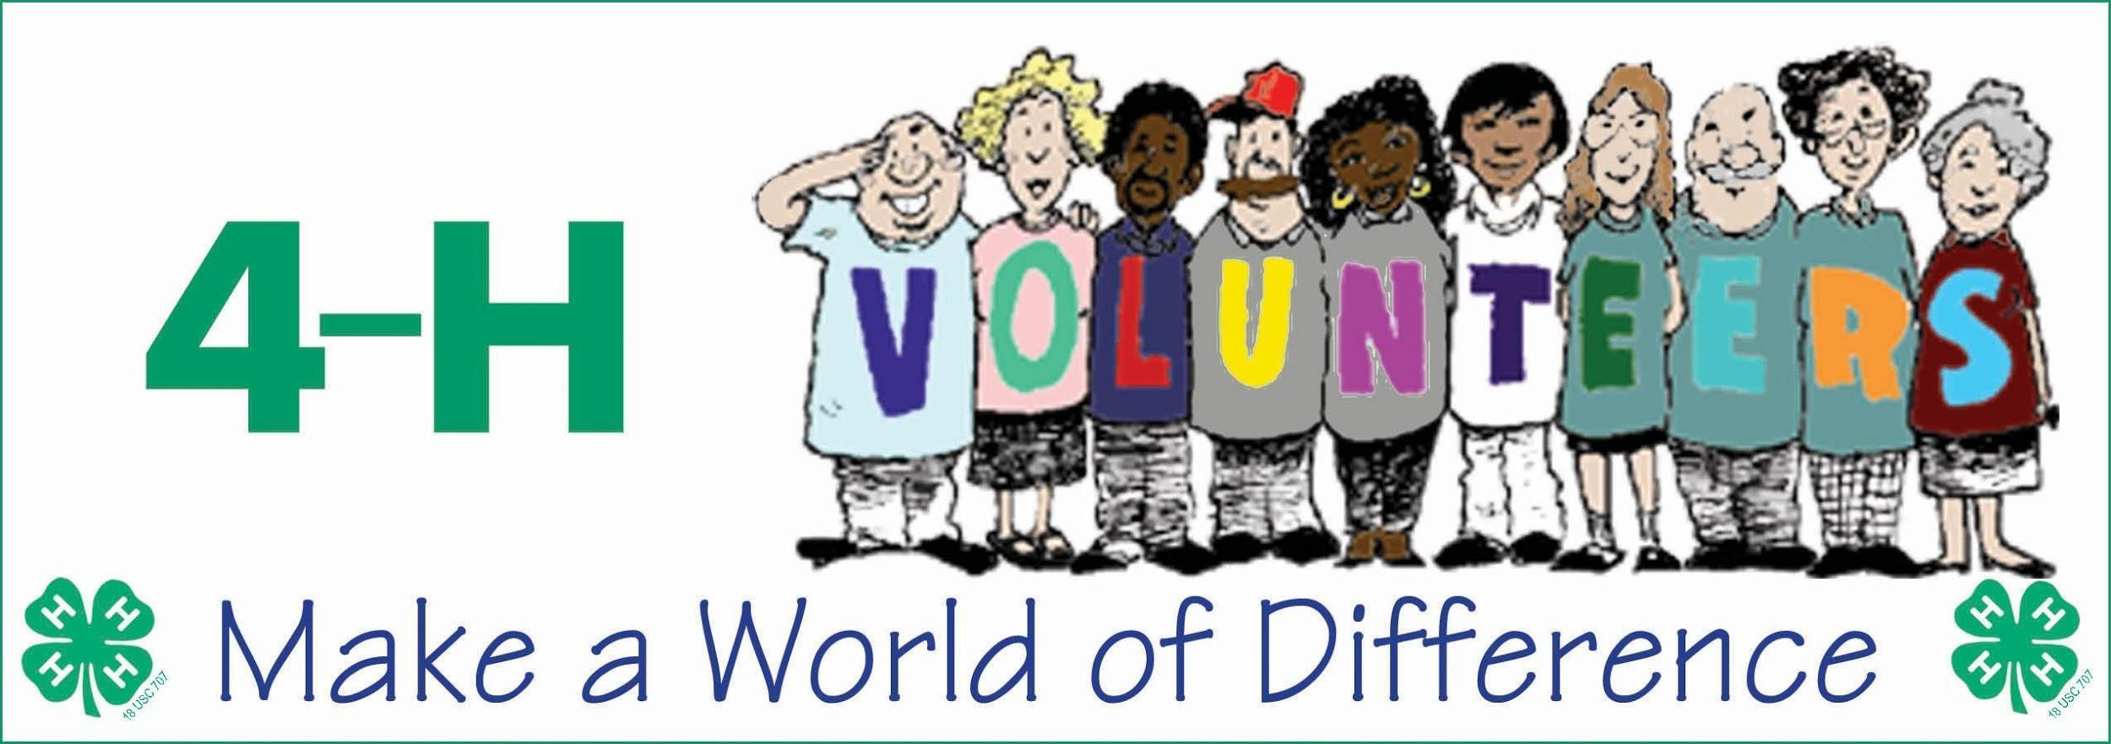
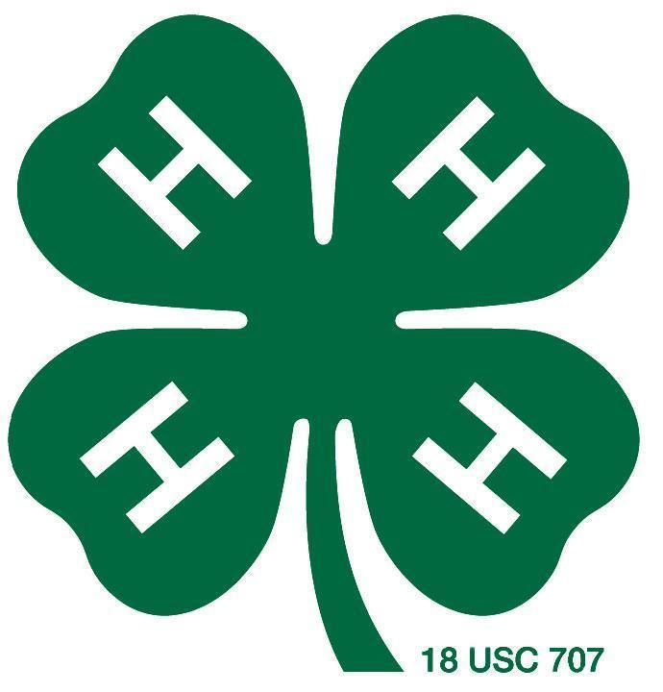
4-H Volunteer Opportunities

4-H Volunteers should also be enrolled in 4-H Online annually. In addition, they must pass a criminal background check, reference check, and go through orientation and training. Link for more information?

NC 4-H Volunteer Leaders’ Association (VLA) 4-H volunteers can participate in county, district and state leaders’ associations. VLA provides opportunities forl trainings and development. The association also offers scholarships to 4-H youth. There is the potential for leadership development by serving as a county, district,or state officer. Contact your local 4-H Staff for county opportunities. Volunteers | NC State Extension
State Contact: Sarah Kotzian, sarah_kotzian@ncsu.edu

NC 4-H Volunteer Leaders’ Conference is normally held in February and provides an opportunity for volunteer leaders to come together, participate in workshops and training, elect new State Association Officers, and recognize the accomplishments of 4-H Volunteers. Contact your local 4-H Staff for county opportunities.
Volunteers | NC State Extension State Contact: Sarah Kotzian, sarah_kotzian@ncsu.edu

Volunteer Conference of Southern States’ primary purpose is to educate and prepare volunteers to share the information acquired at the forum with their own 4-H programs and activities. Participants benefit from the experiential learning activities that require them to discuss, use, and apply what they learn. This event is held annually in October at Rock Eagle 4-H Center in Eatonton, Georgia.
National 4-H Volunteer Conference by the Volunteer Conference of Southern States - 4-H Volunteers Grow Here
Contact: Harriett Edwards, harriett_edwards@ncsu.edu

Volunteer Leader Recognition NC 4-H Volunteer Leaders’ Association (VLA) annually sponsors a statewide volunteer recognition program to formally acknowledge the excellent work of these individuals who give their time, talents and resources in support of the youth participating in North Carolina 4-H programs. Nominations are typically due in December.Volunteers | NC State Extension Contact: Sarah Kotzian, sarah_kotzian@ncsu.edu

4-H Club Leaders 4-H Clubs are volunteer-led with at least two volunteer leaders present at all times.

4-H Middle Managers help to manage 4-H events and programs.

4-H Volunteer Judges are needed to judge 4-H Entertains, Expressive Arts, 4-H Presentations, Project Record Books, and so much more!

Volunteer your talents today!

This document was originally developed by 4-H Staffs in North Carolina (updated 10/22/2021)
Accommodation requests related to a disability should be made ten business days to the contact person listed for the event.
N.C. Cooperative Extension prohibits discrimination and harassment regardless of age, color, disability, family and marital status, gender identity, national origin, political beliefs, race, religion, sex (including pregnancy), sexual orientation and veteran status. NC State University, N.C. A&T State University, U.S. Department of Agriculture and local governments cooperating.
Read more at: Referencing Extension

